# **Application Development – Final Report**

Manisha Gautam – a37446

Mausam Tiwari – a37448

**REPORT CONTENT**

**Application Development – Final Report** 1

**INTRODUCTION** 2

**1.0 APPLICATION LAYER STRUCTURE** 2

**1.1** **ENTITY FRAMEWORK** 2

**1.2 DATABASE** 2

**1.2 BUSINESS LAYER** 3

**2.0 IMPLEMENTATION OF THE FUNCTIONALITIES** 3

**2.1 SESSION** 3

**2.2 ADMIN FUNCTION** 3

**2.3 USER EMAILS DONOR** 3

**2.4 ADMIN CREATES/RETRIEVE/UPDATE/DELETE** 3

**2.5 USER DECIDES IF HE/SHE STILL WANTS TO BE APPEARED AS DONOR** 3

# **INTRODUCTION**

The main objective of our application is to record the database of the people who wish to donate or receive blood. We have named our application “**HAMRO BLOOD BANK**”. Basically, anyone can use our application. Any one who wish needs blood can send message to the registered donors of the respective blood groups and requests for the donation. And it is up to the donors who are registered to donate the blood.

To register as an administrator, all the required credentials already saved in the database should be entered. There is a Boolean function which checks if the entered credentials match to log in to the administrator account

## **ENTITY FRAMEWORK**

Entity Framework Core (EF Core)(Code-first approach) the latest version of Microsoft's recommended data access technology for application has been implemented in our application.

# **1.2 DATABASE**

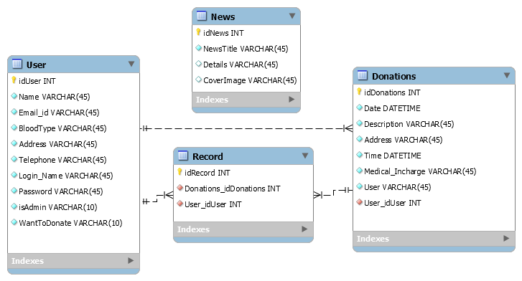

# **BUSINESS LAYER**

We have 4 classes

1.User – Are the users of the application , They can be a registered users or an admin or even a normal user .

2.Donation- Is the table that has the informations of the Donations that are made by the Registered Users.

3.News- Is the news or the events that are taking place time and again and which can only be created or updates or deleted by the Admin for the normal users to see and keep updated.

4.Record-Is the record of the Registered user who are actively taking part in the Donations.

# **2.0 IMPLEMENTATION OF THE FUNCTIONALITIES**

# **2.1 SESSION**

We have implemented session state here in our application. Whenever somebody logs into the application a .txt file is created into the device which stores the login Credentials. Which then later are used to differentiate if the user is logged and if the user is either admin or the normal.

A attribute in the table User IsAdmin carries the Boolean value to decide if the user is admin or not ,This value has to be set through the database for a user to become a admin.

For now the Credential for the Admin are

**Login – Admin**

**Password-admin**

# **2.2 Hidden Buttons**

When a normal user logs in to his account the buttons which are visible to admins are hidden automatically like below.

Fig:buttons Add New News and Edit News only visible to the admin of the application.

Similary there are other buttons which are only visible to the loggedin Users which allows them to Upate their informations , to stop being a donor and to record the donations they have made.

# **2.3 USER EMAILS DONOR**

When any application user needs blood. He can go to the Search Donor page and they can make a search for their matching blood group. The application will display the Donors of the same blood group.a He can then asks donors of his/her respective blood group for the donation. He sends an email to donor. And then he/she gets reply of the email sent if the donor wishes to donate the blood.

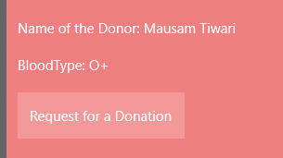

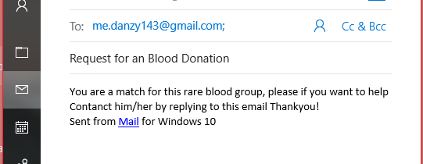

An email will be then sent asking if the Donor is willing to make a donation.

# **2.4 USER DECIDES IF HE/SHE STILL WANTS TO BE APPEARED AS DONOR, He/She can update their informations.**

We have also added a functionality for donors so that After a certain time of him becoming a Donor if he no longer can continue to donate ,he can choose to stop becoming a donor which means donation seekers can no longer contact him asking for donation. A donor has a leave option and be a normal user.

**2.5.** The initial Concept was of the page Donors Near me in our project was to pin the Registered Users in the map based on their addresses. But due to complexity we just added the mad and left it as it is.

